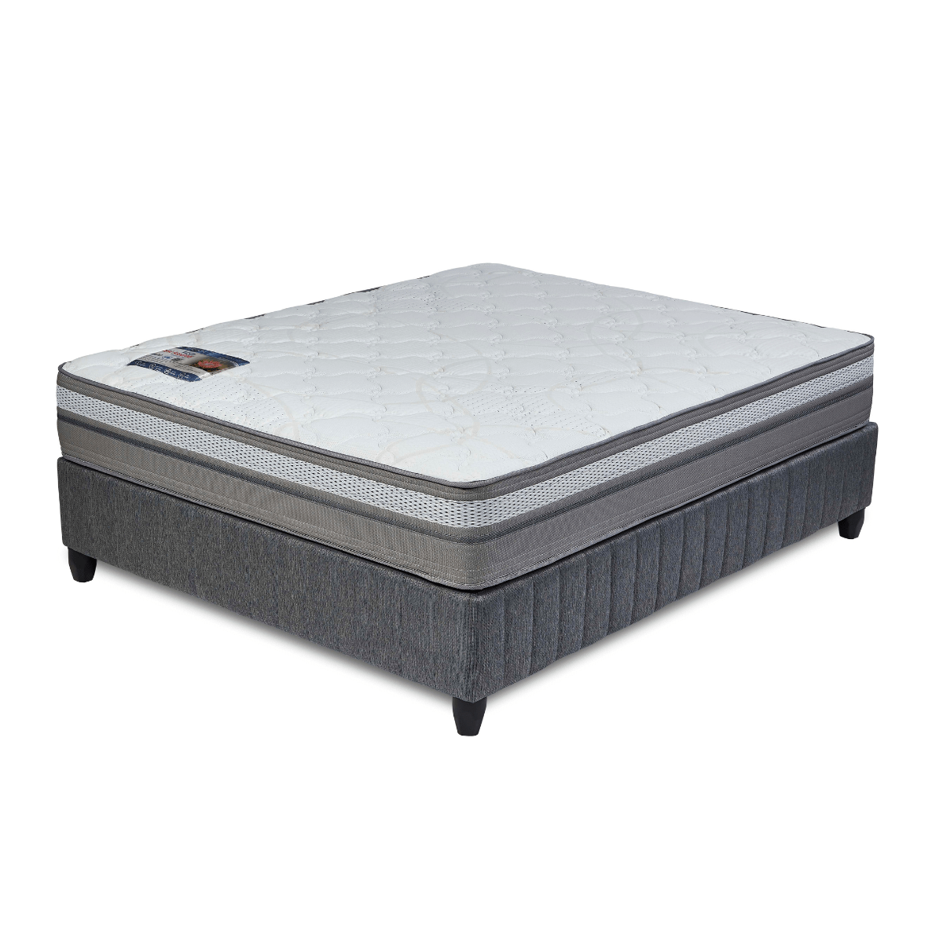


Model : Somerset Base Set
Supplier/Manufacturer : Rest Assured
Range : Evolution Pocket Spring Collection
Prices – Bed Set :
- Single Bed Set – R6129
- Three Quarter Bed Set – R6899
- Double Bed Set – R8169
- Queen Bed Set – R8819
- King Bed Set – R11309
Prices – Mattress Only :
- Single Mattress Only – R4479
- Three Quarter Mattress Only – R5069
- Double Mattress Only – R6139
- Queen Mattress Only – R6739
- King Mattress Only – R7999
Prices - Extra Length Bed Set :
- Single Extra Length Bed Set – R6619
- Three Quarter Extra Length Bed Set – R7449
- Double Extra Length Bed Set – R8829
- Queen Extra Length Bed Set – R9529
- King Extra Length Bed Set – R12219
Prices - Extra Length Mattress Only :
- Single Extra Length Mattress Only – R4839
- Three Quarter Extra Length Mattress Only – R5479
- Double Extra Length Mattress Only – R6629
- Queen Extra Length Mattress Only – R7279
- King Extra Length Mattress Only – R8639

*Please use this link for guideline for creating the page* - https://www.bedsonline.co.za/product/rest-assured-somerset-king/
Rest Assured Link - https://restassured.co.za/our-ranges/evolution/somerset/

